**MS Excel – Project**

Create the name range for birth rate and income group.

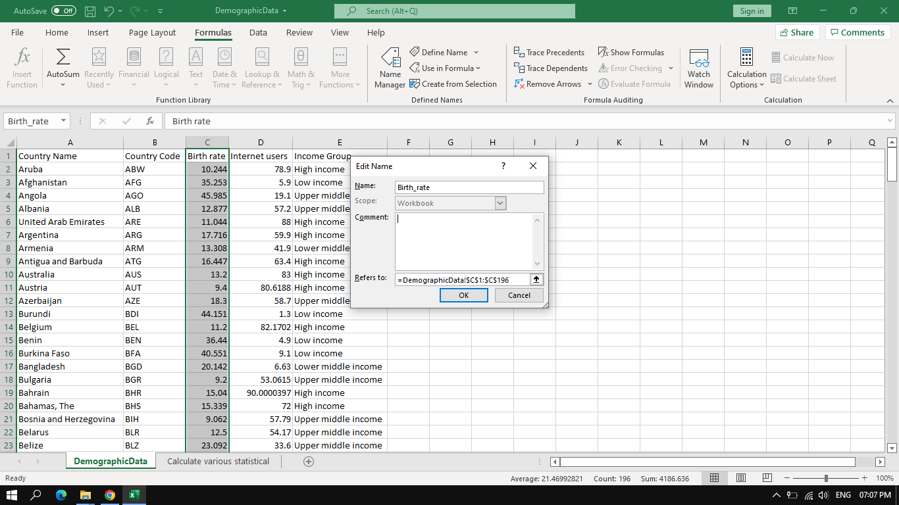

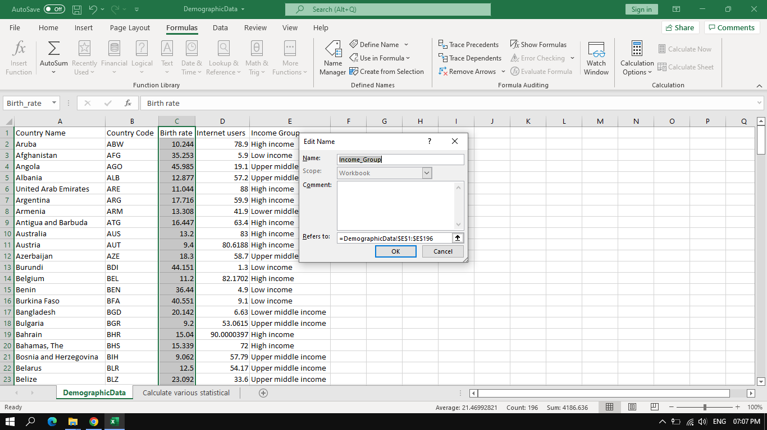

Calculate various statistical details:

* 1. Mean of birth rate and internet users.

|  |  |  |  |
| --- | --- | --- | --- |
| Mean of birth rate |  |  | 21.46993 |
| Mean of internet users |  |  | 42.07647 |

* 1. Median of birth rate and internet users.

|  |  |  |  |  |
| --- | --- | --- | --- | --- |
| Median of birth rate |  |  |  | 19.68 |
| Median of internet users |  |  |  | 41 |

* 1. Variance of birth rate and internet users (consider both the population and sample variances).

|  |  |  |  |  |
| --- | --- | --- | --- | --- |
| **population variances** |  |  |  |  |
| population variances of birth rate |  |  |  | 111.8991 |
| population variances of internet users |  |  |  | 838.4647 |
|  |  |  |  |  |
| **sample variances** |  |  |  |  |
| sample variances of birth rate |  |  |  | 112.4759 |
| sample variances of internet users |  |  |  | 842.7867 |

* 1. Standard deviation of birth rate and internet users (consider both the population and sample standard deviations).

|  |  |  |  |  |  |  |
| --- | --- | --- | --- | --- | --- | --- |
| **population standard deviations** |  |  |  |  |  |  |
| population standard deviations of birth rate |  |  |  |  |  | 10.57824 |
| population standard deviations of internet users |  |  |  |  |  | 28.95625 |
|  |  |  |  |  |  |  |
| **sample standard deviations** |  |  |  |  |  |  |
| sample standard deviations of birth rate |  |  |  |  |  | 10.60547 |
| sample standard deviations of internet users |  |  |  |  |  | 29.03079 |

* 1. IQR of birth rate and internet users.

|  |  |  |
| --- | --- | --- |
| IQR of birth rate |  | 17.639 |
| IQR of internet users |  | 51.705 |

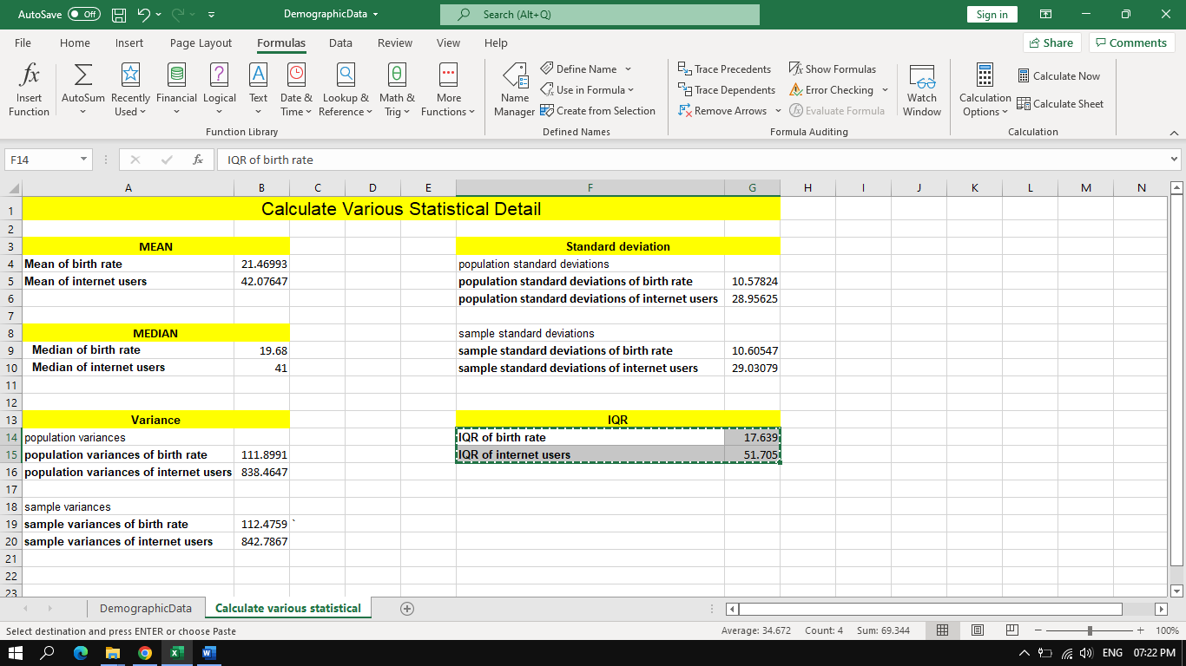

Create filters on country and income groups:

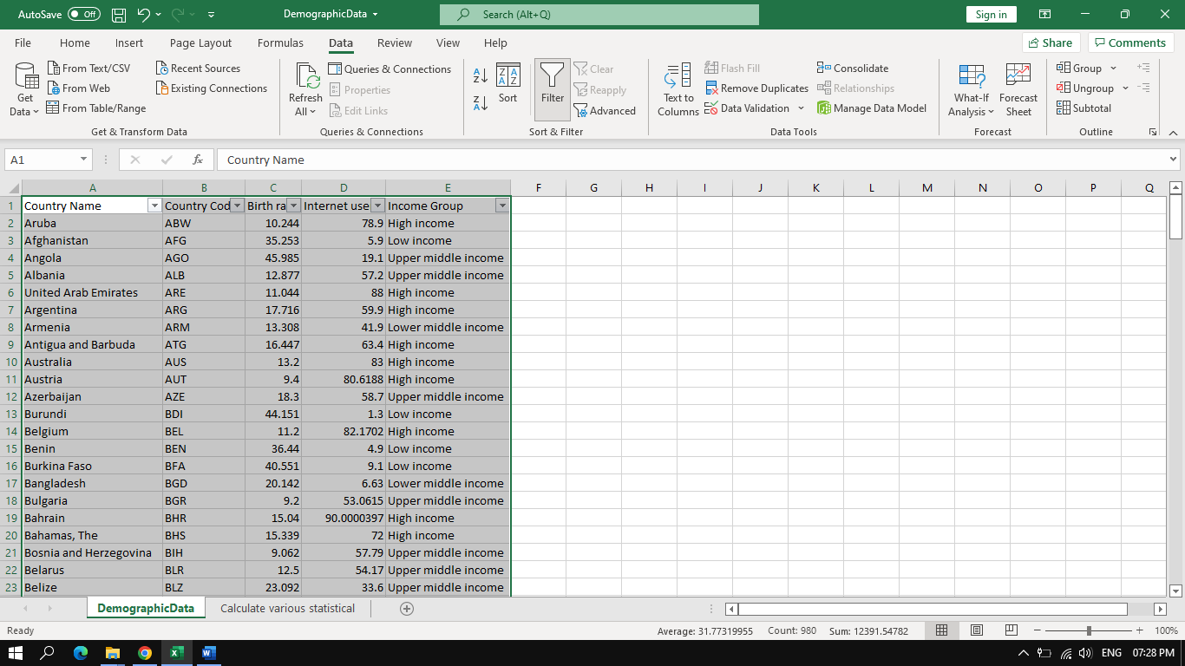

1. Use the country filter and check which income group India falls under.

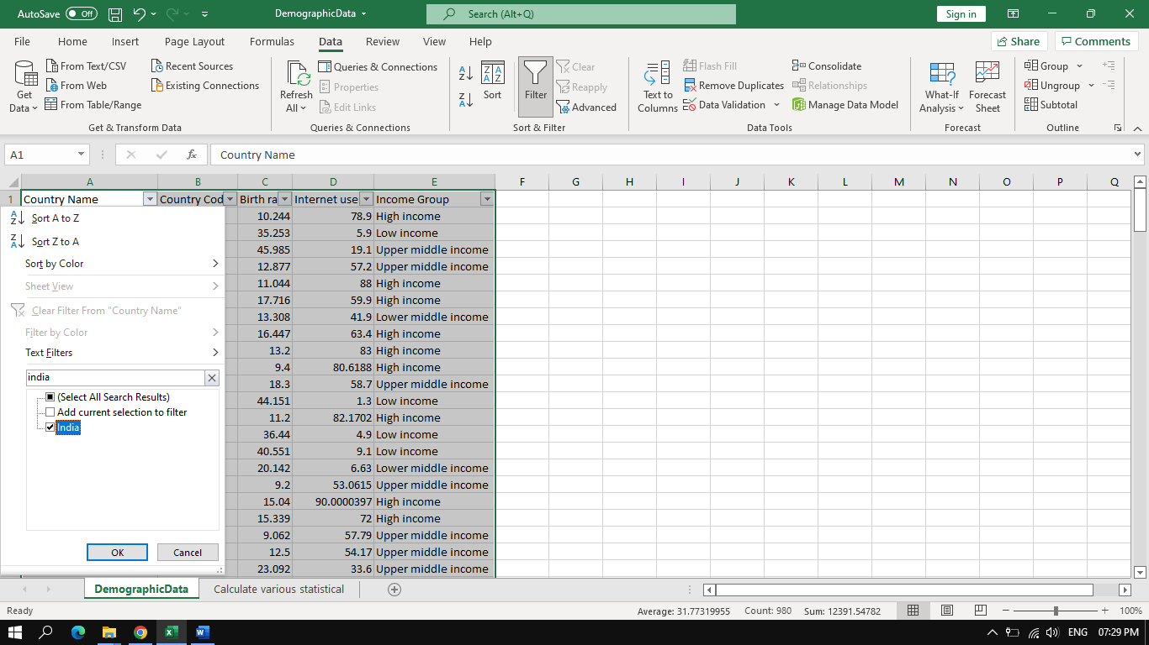

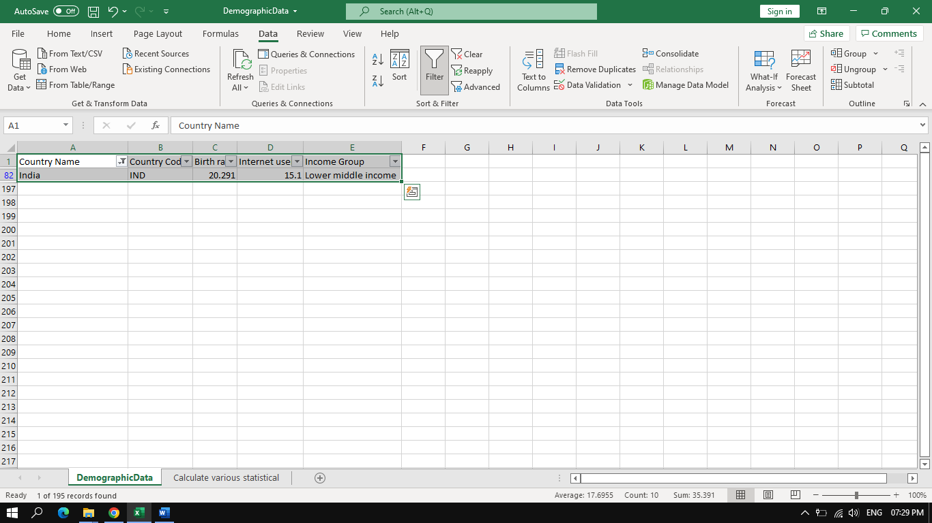

India fall under Lower middle income group.

1. Filter all the countries of the same income group as India and take the count of countries.

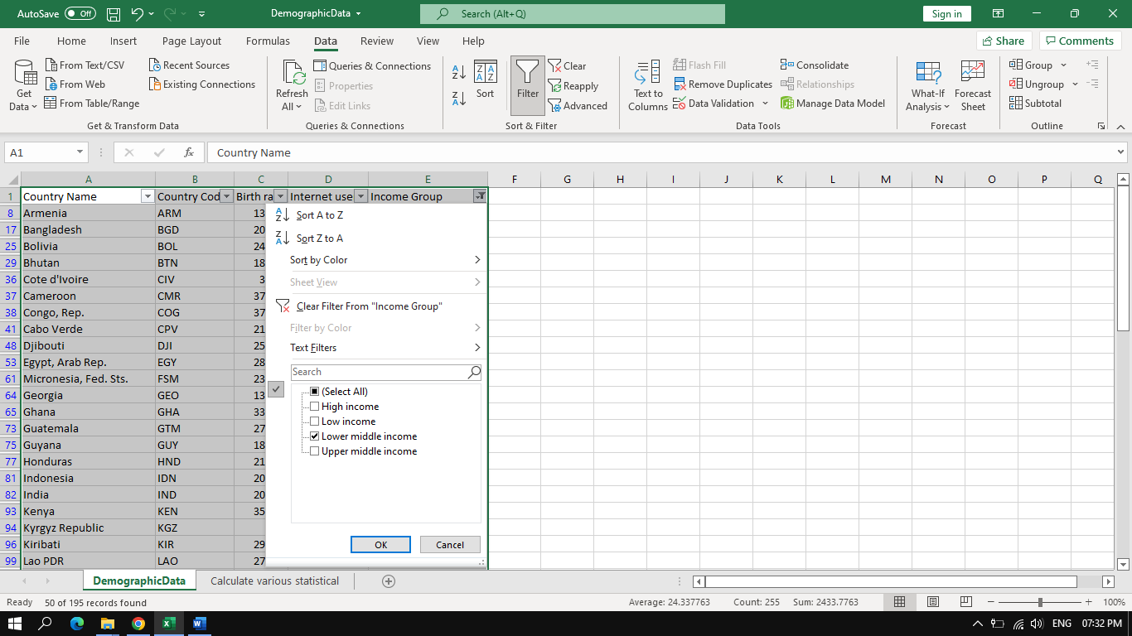

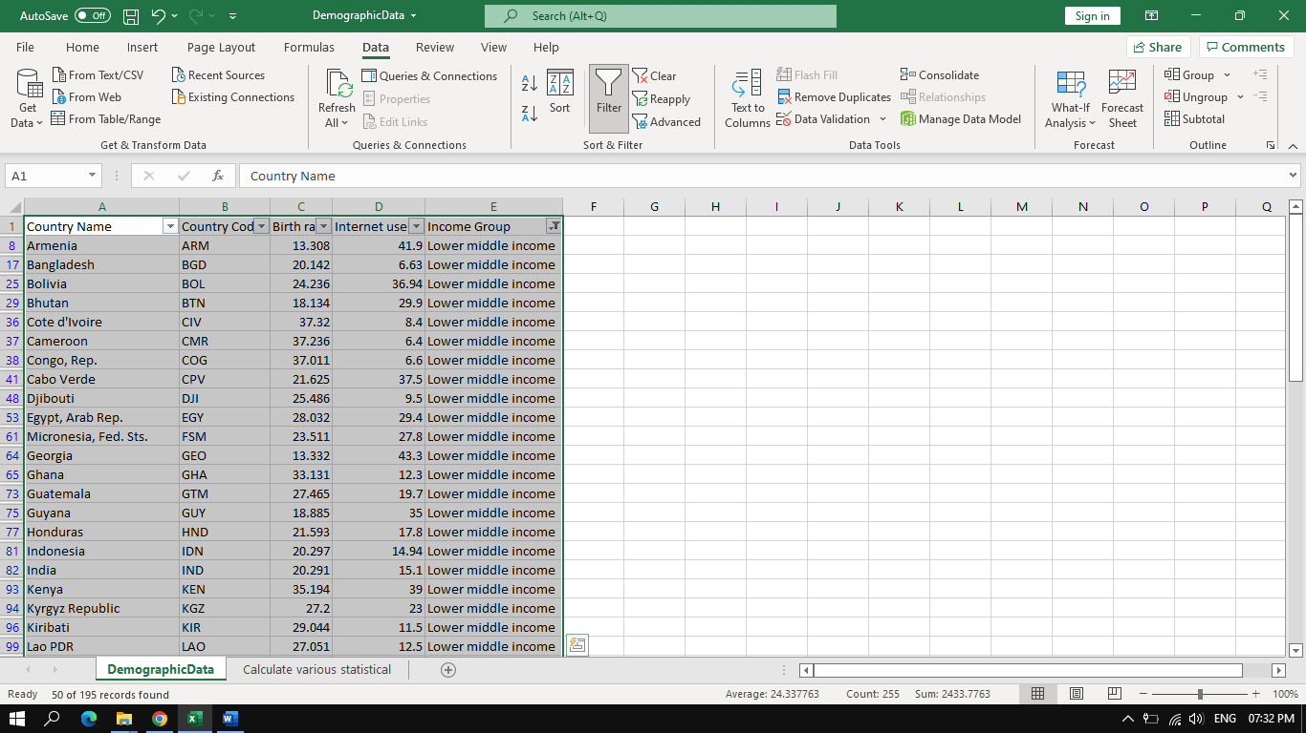

There are total 50 countries which come under same income group as india.

Create the pivot table and add country, income group, and internet users in the same Excel sheet.

